**Deploy a microservice based Web Application to Azure Kubernetes Service (AKS)**

Agenda:

1. Hosting application on AKS Cluster

2. How to create the docker image

3. How to push the docker to ACR Push

4. How to secure sensitive information like DB credentials, client ID, client secret using keyvault.

5. How to check any logs and error while deploying on AKS cluster

Teams Involved:

1. Devops- CICD pipelines setup, automation, IaC etc
2. App team- app development
3. Security team- Certs (.crt, .pfx) creation
4. DNS team- to create DNS records (A record, CN name, etc)
5. Infra Team- to provide azure infrastructure, app GW config, etc.
6. Azure AD admin team- for app registration, access control, etc.
7. Prod support team- Incident mgmt., reporting, RCA, etc.
8. Testing team.

Azure Devops (ADO) (dev.azure.com)- Project Setup

1. Project creation in ADO, provide access to new members, user stories mgmt. based on agile, scrum model, etc.
2. Create service connections for sonarqube, ACR (for dev, qa, sit, uat, prod), AKS cluster (for dev, qa, sit, uat, prod),

using Terraform, create namespaces on the cluster (for dev, qa, sit, uat, prod).

1. Agent pool configuration, etc.
2. Create repositories (Azure repos for frontend- Angular/ Backend in .net core, Ingress)
3. Setup pipelines. (Build/Release)

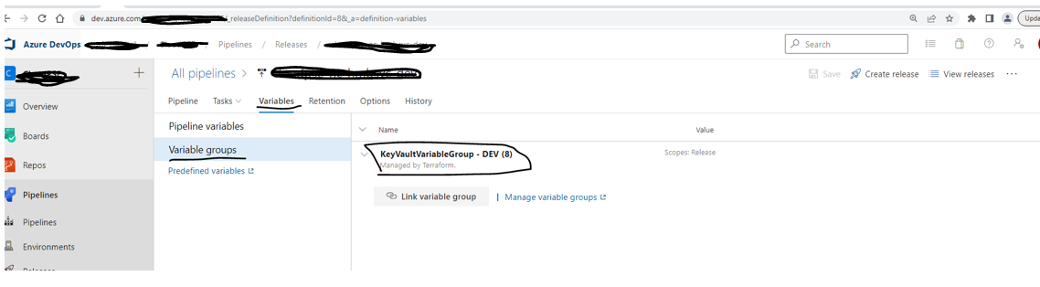

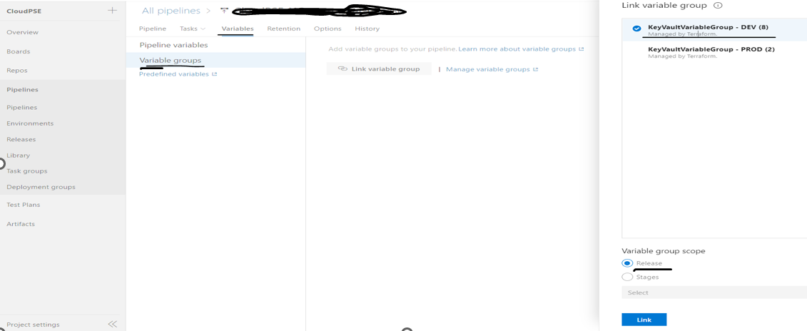

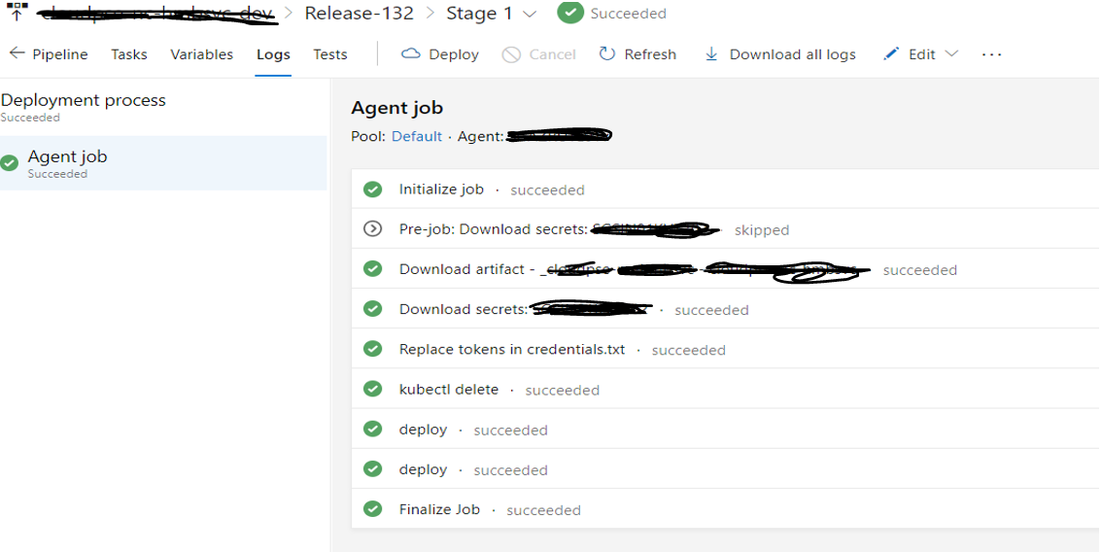

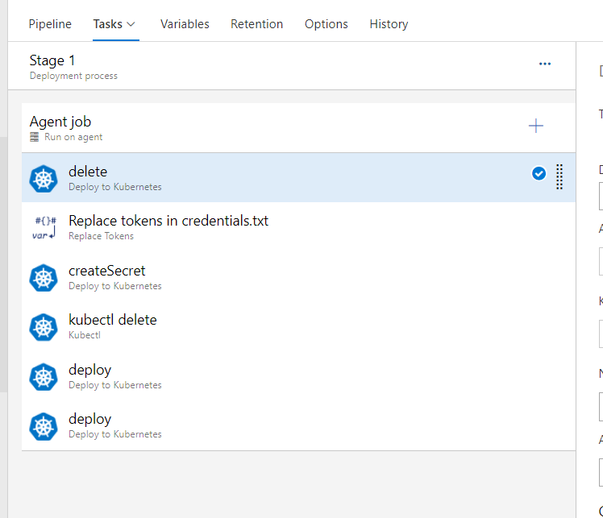

Azure cloud (portal.azure.com)- Resource Creation

1. Shared dashboard
2. Application Insights
3. SQL database
4. Storage account
5. Log Analytics workspace
6. Container registry
7. Application gateway
8. Kubernetes service
9. Key vault
10. Managed Identity

Azure resources creation using Terraform:

<https://developer.hashicorp.com/terraform/tutorials/azure-get-started/azure-build>

Responsibility Metrix:

|  |  |  |
| --- | --- | --- |
| # | Task Name | Responsibility |
| 1 | Raise request to bind the - Internal (private) IP - with DNS | App team->DNS team |
| 2 | Create SSL cert | App team->Security team |
| 3 | Configure SSL cert to application gateway. | Devops |
| 4 | New Repository and required branches (Frontend, Web API Services, Python service) need to be created for Production like Dev, QA | Devops |
| 5 | Provide name of reviewers to add into branch policies for PR approval. | App team |
| 6 | Require access to Dev team for moving the code from QA branch to production (via PR) | Devops |
| 7 | Need to create build pipeline | Devops |
| 8 | Need to create release pipeline in DevOps for prod | Devops |
| 9 | Need to create new database instance for production | Devops |
| 10 | Setup Azure dashboard | Devops |
| 11 | Setup App insights | Devops |

Create build pipeline: Frontend (Angular) using yml scripting

Ex.

# Docker

# Build and push an image to Azure Container Registry

# https://docs.microsoft.com/azure/devops/pipelines/languages/docker

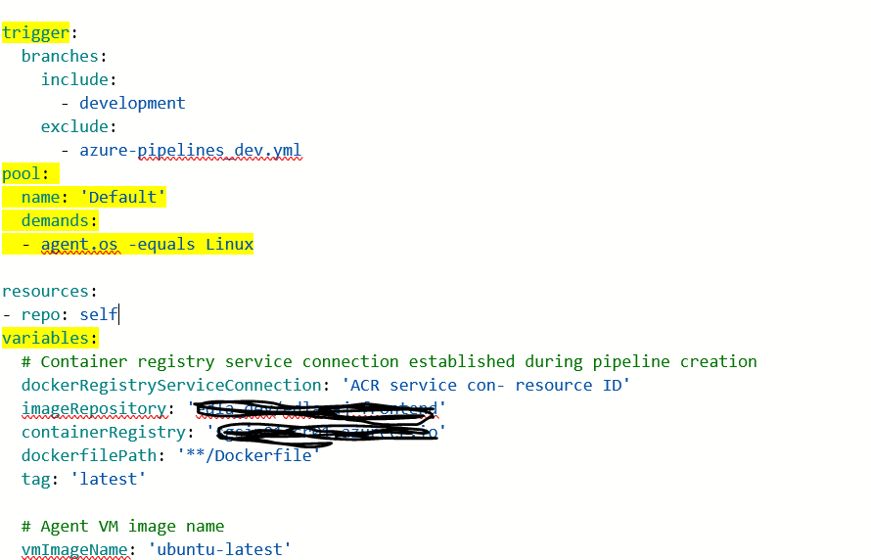

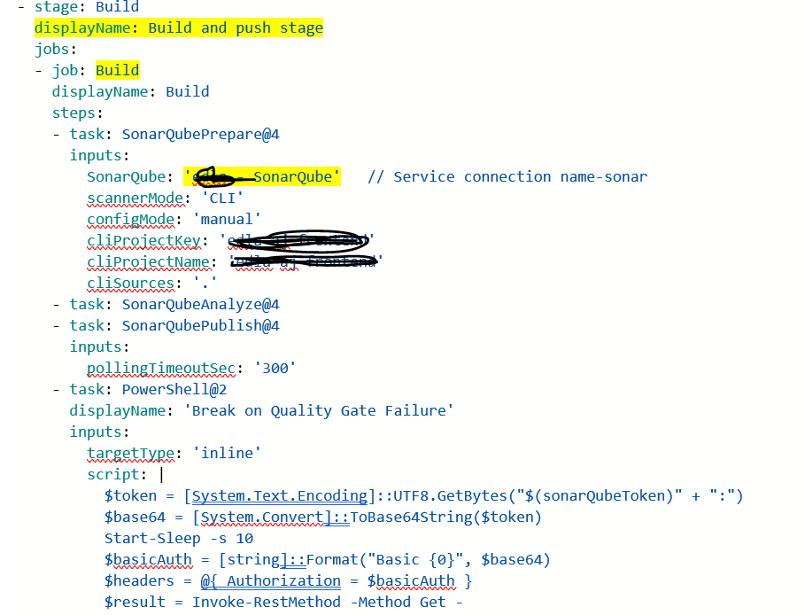

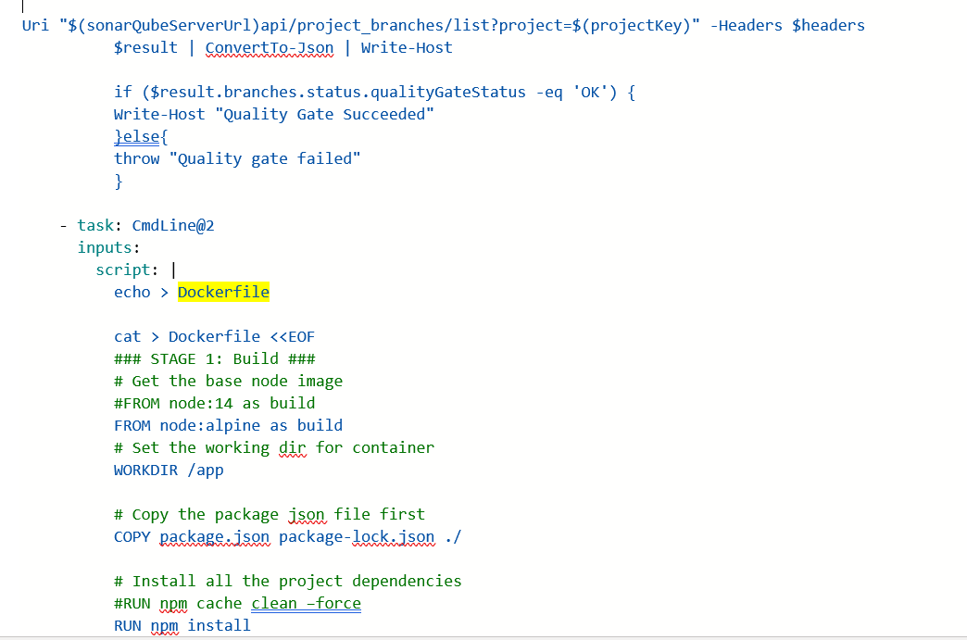

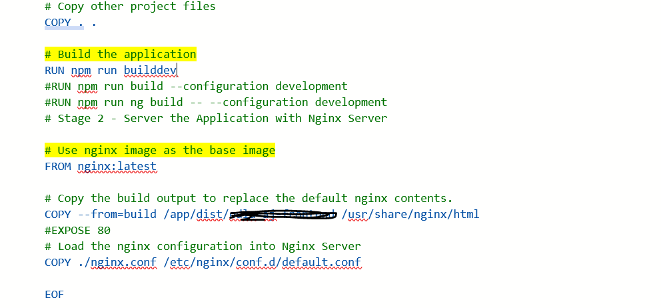

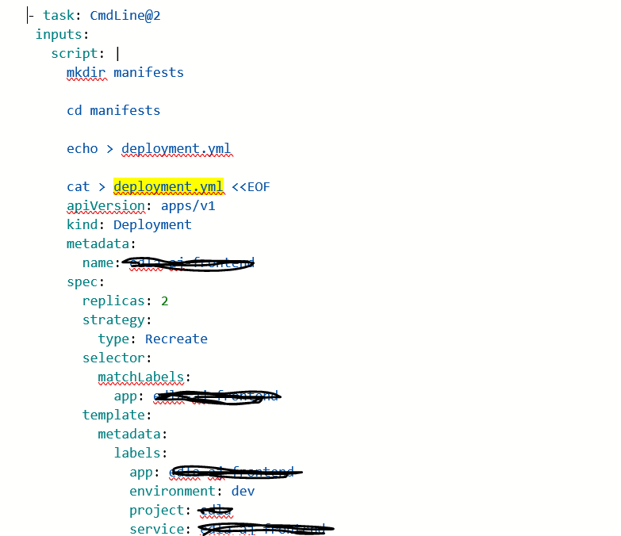

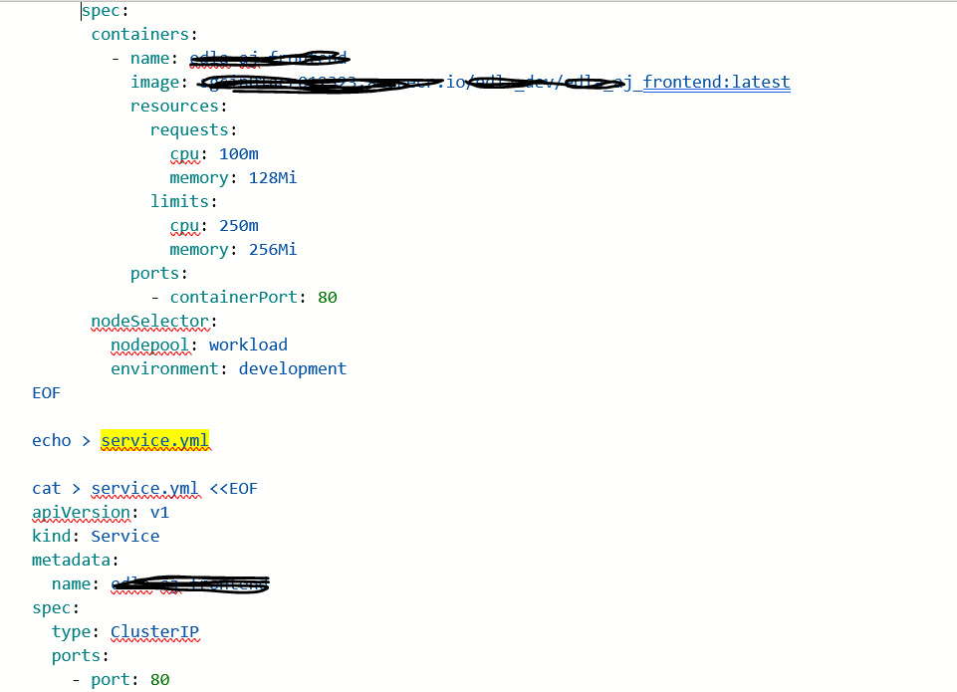

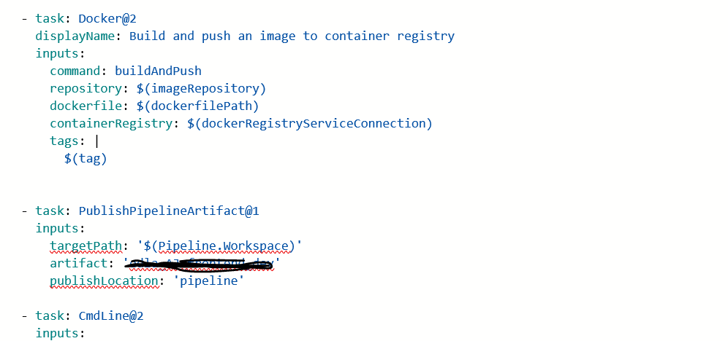

Create release:

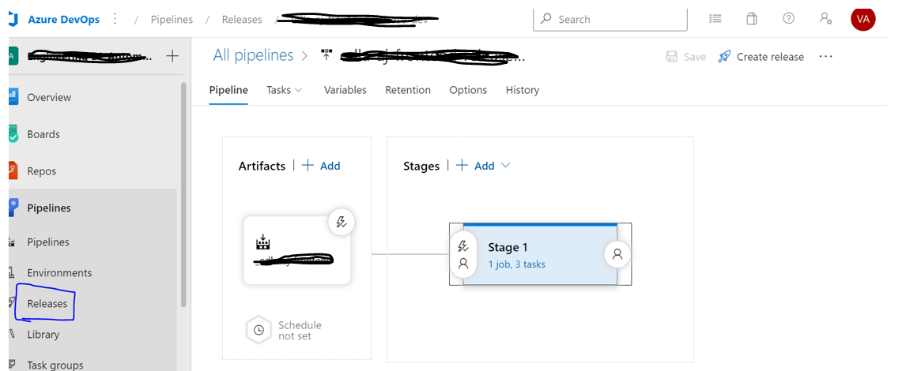

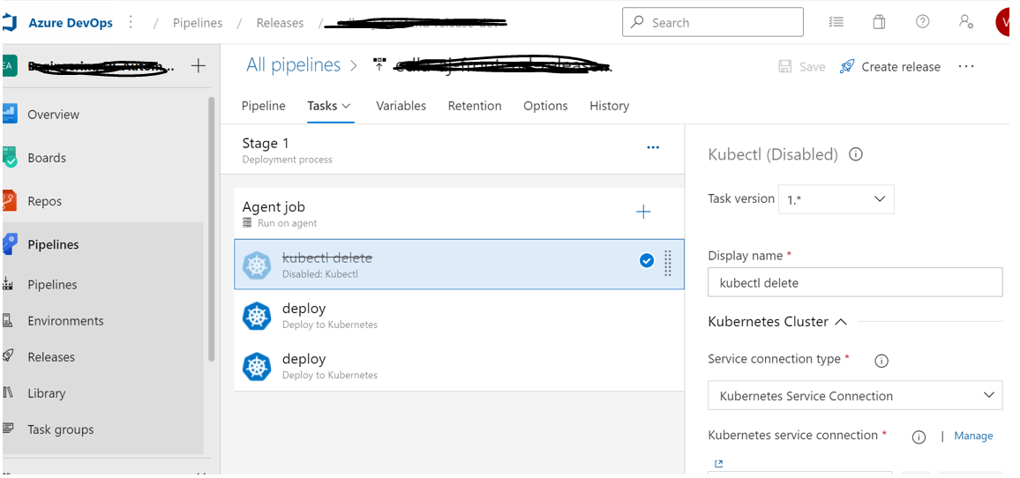

Connect to the aks cluster: Troubleshooting to find & fix errors

